Ticketing Screen Designer – User manual

Contents

Quick Start 3

First time setup 9

Default password 9

Local database setup 9

Remote database setup 11

Configuration file format 12

Local database with SSPI (Windows) authentication 12

Local database with SSPI (Windows) authentication and a different name 12

Remote database with SSPI (Windows) authentication 12

Local database with SQL server authentication 12

Local database with SSPI (Windows) authentication 13

# Quick Start

1. Register your bank. Enter the bank name into the text box in the “Register” section, and choose a password. Type your password again to confirm, then click “Register”.

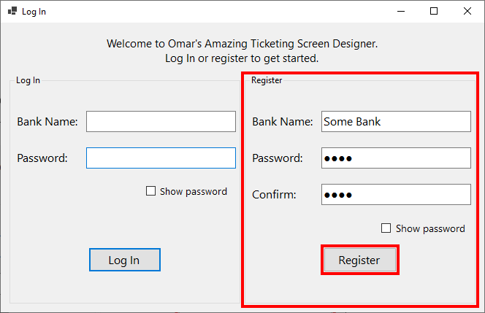

1. If registration is successful, you can log in. Enter the name of the bank and the password into the login text boxes, then click “Log In”.

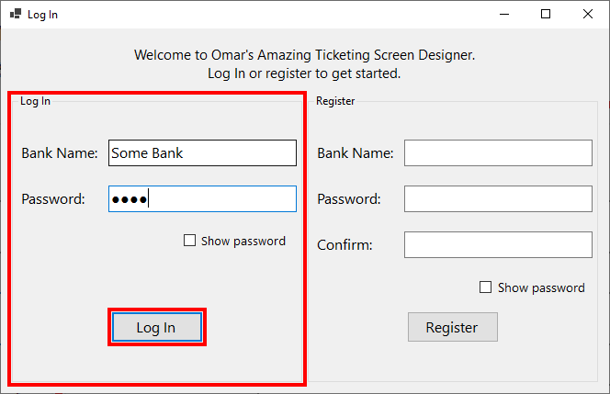

1. You’ll see the following form. Click “Add” to begin adding a screen.

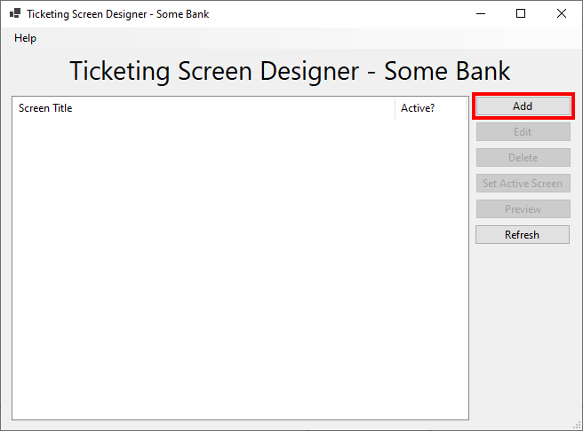

1. This will open up another form for editing your screen. Starting by typing in a title for your screen. This is the title that will be shown to your customers.

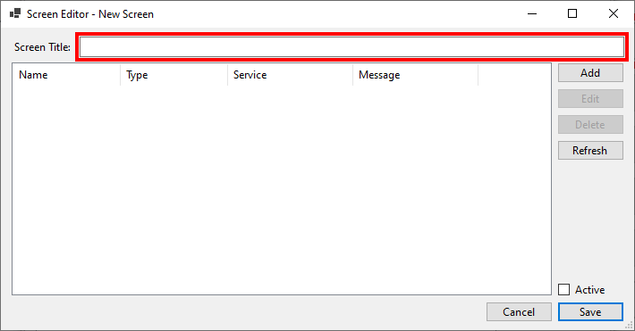

1. You can now start adding buttons to your screen. Click on “Add” to create your first button.

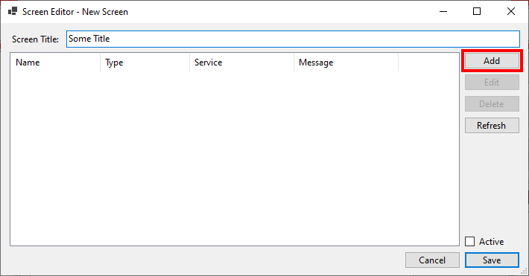

1. This will open up the button editor form. Type in the name of your button in English and in Arabic. This is the name that will be shown to your customers.

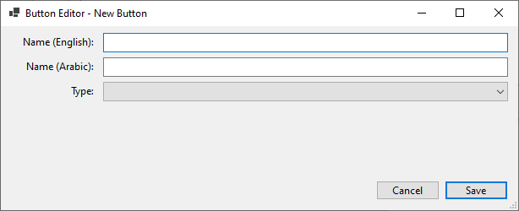

1. Set the type of your button to “Issue Ticket” or “Show Message”. Depending on the type you choose, you will get different fields to fill in. Fill in the desired information, then click “Save”, or press “Enter” on your keyboard.

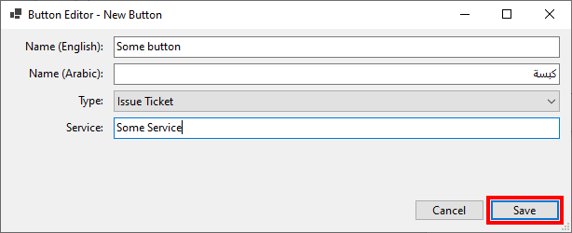

1. You should now see the button you just added in the list of the screen editor.

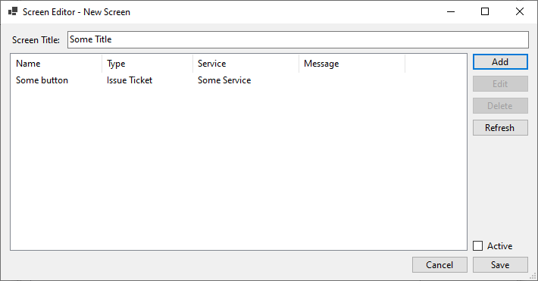

1. Click “Save”, or press “Enter” on your keyboard to save the screen.

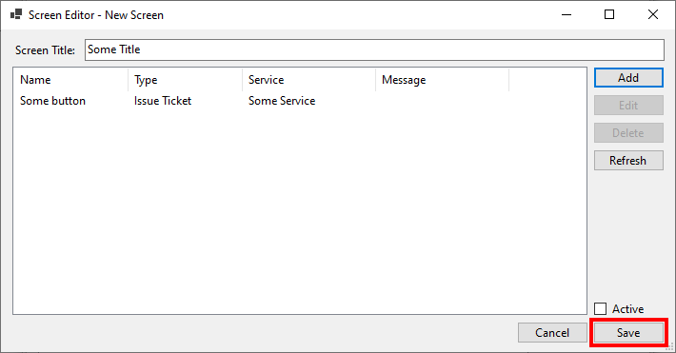

1. You should now be able to see the newly added screen in the list.

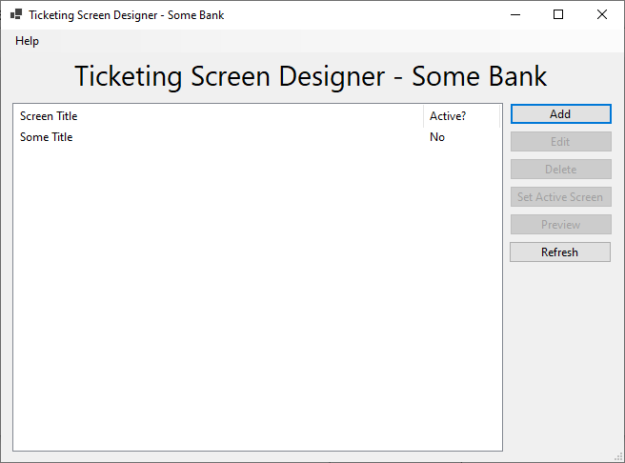

1. If you decide to change the information for the screen, click on the screen in the list, then click “Edit” to modify it.

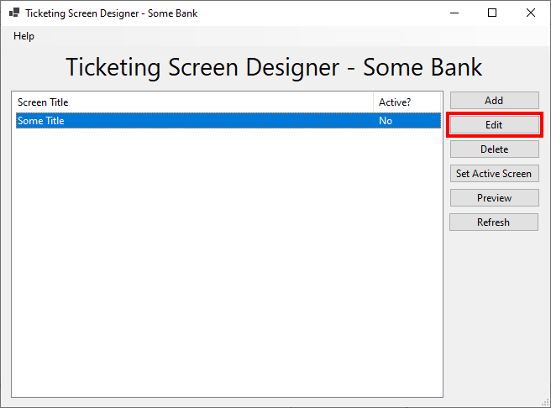

1. If you would like to see what your screen would look like, select it, then click “Preview”.

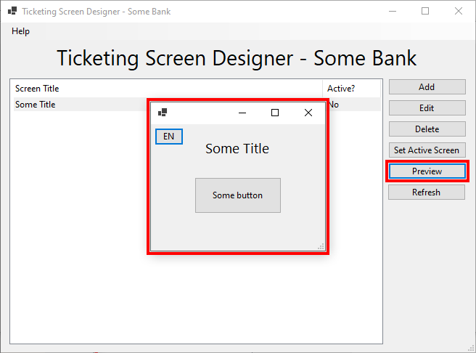

1. To set the active screen, select it from the list, then click “Set Active Screen”. Please note that you can only have one active screen at a time.

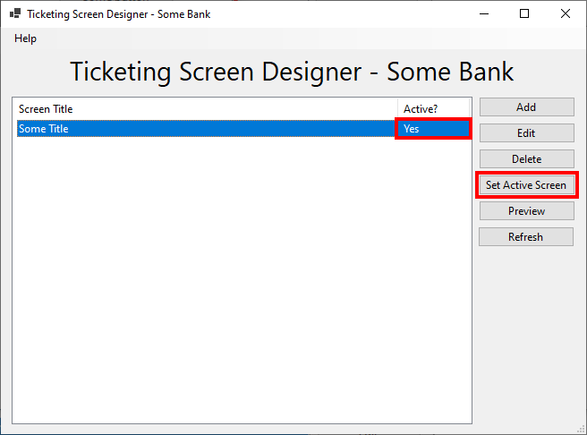

# First time setup

## Default password

If your bank was already registered in the database before passwords were required, you can log in with the same bank name, and the password “defpass”.

## Local database setup

1. Make sure you have Microsoft SQL Server and SQL Server Management Studio (SSMS) installed on your machine.
2. Open SSMS and connect to your desired database engine. Note that you need database creation privileges to proceed.
3. Open the file named “DB_setup.sql” using SSMS.
4. In the menu bar, click “Query”, then click “SQLCMD Mode”.

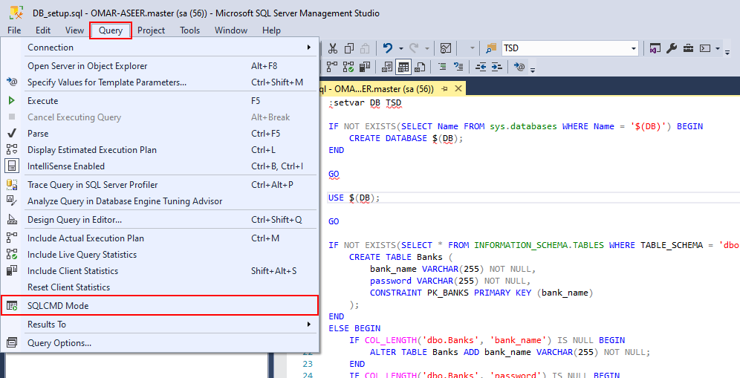

1. Note that the words previously underlined in red should no longer be highlighted.
2. If you would like to name the database to something other than “TSD”, change the name in the first line of the script. Note that the name should not contain any spaces. Make sure you update the configuration file to the same name.

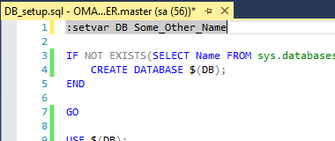

1. Make sure you are on the “master” database.
2. Execute the query by clicking “Execute” or pressing “F5” on your keyboard.

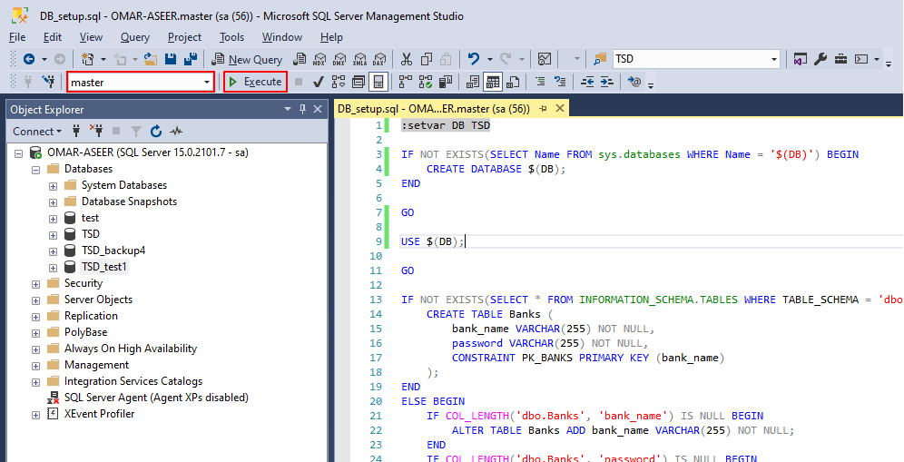

## Remote database setup

1. Open the directory where the application is installed, then navigate to /bin/config.
2. Open the file named "DB_config.txt" in your preferred text editor.

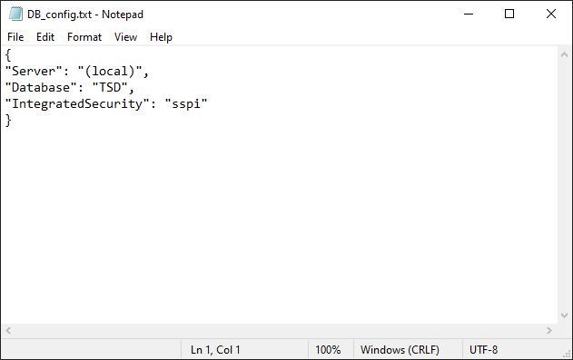

1. Change the “Server” field, which is set to “(local)” by default, to “11.0.0.151\MSSQLSERVER”.

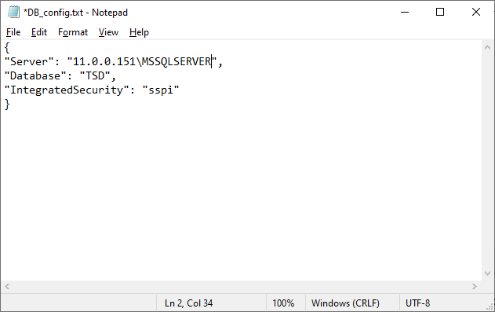

1. Save the text file and close it before starting the application.

# Configuration file format

To access the configuration file, open the directory where the application is installed, then navigate to /bin/config.

If you change the configuration file, make sure you save and close it, then restart the application to see your changes.

## Local database with SSPI (Windows) authentication

{

"Server": "(local)",

"Database": "TSD",

"IntegratedSecurity": "sspi",

}

## Local database with SSPI (Windows) authentication and a different name

{

"Server": "(local)",

"Database": "Some_Other_Name",

"IntegratedSecurity": "sspi",

}

## Remote database with SSPI (Windows) authentication

{

"Server": "11.0.0.151\MSSQLSERVER",

"Database": "TSD",

"IntegratedSecurity": "sspi",

}

## Local database with SQL server authentication

{

"Server": "(local)",

"Database": "TSD",

"UserId": "<your_username>",

"Password": "<your_password>",

}

## Local database with SSPI (Windows) authentication

{

"Server": "11.0.0.151\MSSQLSERVER",

"Database": "TSD",

"UserId": "<your_username>",

"Password": "<your_password>",

}